Shearing:

It is transformation which changes the shape of object. The sliding of layers of object occur. The shear can be in one direction or in two directions.

**Shearing in the X-direction:** In this horizontal shearing sliding of layers occur. The homogeneous matrix for shearing in the x-direction is shown below:

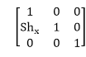  
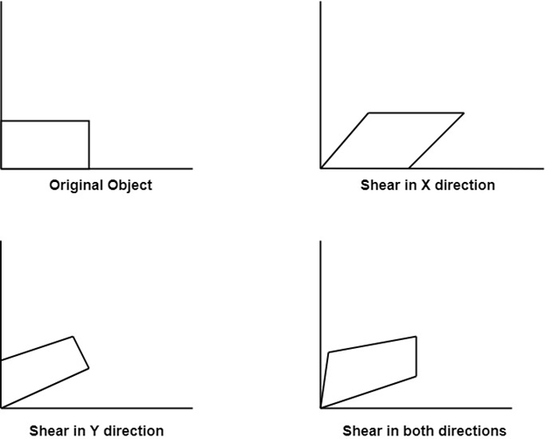

**Shearing in the Y-direction:** Here shearing is done by sliding along vertical or y-axis.

Shearing

**Shearing in X-Y directions:** Here layers will be slided in both x as well as y direction. The sliding will be in horizontal as well as vertical direction. The shape of the object will be distorted. The matrix of shear in both directions is given by:

